***TESTE DE LED/SETA DE CARRO***

Foto do projeto:  
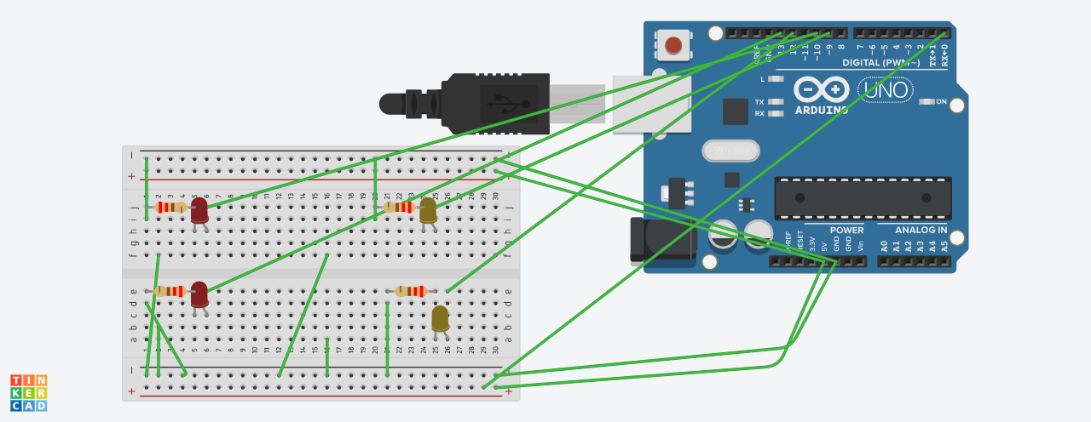

Programação:

// C++ code

//

void setup()

{

pinMode(13, OUTPUT);

pinMode(12, OUTPUT);

pinMode(11, OUTPUT);

pinMode(10, OUTPUT);

}

void loop()

{

digitalWrite(13, HIGH);

digitalWrite(12, LOW);

digitalWrite(11, LOW);

digitalWrite(10, HIGH);

delay(5000); // Wait for 1000 millisecond(s)

digitalWrite(13, LOW);

digitalWrite(12, HIGH);

digitalWrite(11, HIGH);

digitalWrite(10, LOW);

delay(5000); // Wait for 1000 millisecond(s)

digitalWrite(13, HIGH);

digitalWrite(12, HIGH);

digitalWrite(11, HIGH);

digitalWrite(10, HIGH);

delay(5000); // Wait for 1000 millisecond(s)

}